|  |  |
| --- | --- |
|  | **Year 11 ATAR Human Biology**  **Task 2 – Cells, metabolism and enzymes** |

|  |  |  |  |
| --- | --- | --- | --- |
| **Name:** | **Teacher:** | **Date:** | **Score: /50** |

**Assessment type:** Test

**Conditions**

Time for the task: 55 minutes

**Task weighting** - 5%

Total 55 marks

|  |  |
| --- | --- |
| **Multiple Choice** | **/10** |
| **Short Answer** | **/30** |
| **Extended Response** | **/10** |
| **Total:** | **/50** |
|  | **%** |

**Section 1: Multiple-choice (10 marks)**

This section has 10 questions. Answer all questions by circling your choice.

Remember to only choose **one** answer.

1. Homeostasis is:
2. when all cells are kept the same.
3. when the muscle cells work to keep the cellular environment constant.
4. when body systems work together to maintain a constant cellular environment.
5. when the respiratory system works to keep the circulatory system cellular environment the same.
6. Osmosis is the movement of:
7. water (solvent) molecules into a cell.
8. solute molecules into a cell.
9. water (solvent) molecules from a concentrated solution to a dilute solution.
10. water (solvent) molecules from a dilute solution to a concentrated solution.
11. What method of transporting materials in or out of a cell is represented by the diagram shown below?

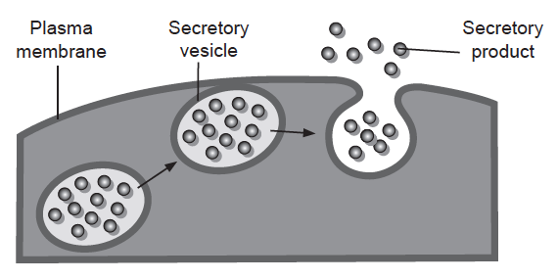

1. Endocytosis.
2. Facilitated diffusion.
3. Active transport.
4. Exocytosis.
5. Which of the following substances could pass directly through the bi-lipid layer of the cell membrane?
6. Alcohol.
7. Salt.
8. Glucose.
9. Bacteria.
10. The first phase in the breakdown of glucose is called:
11. glycolysis.
12. the Krebs cycle.
13. the citric acid cycle
14. the electron transport system.

Use the following information to answer questions 11 and 12. The diagram below represents a “lock and key” model for the chemical reaction in which the enzyme lipase breaks down fats in to fatty acids and glycerol.

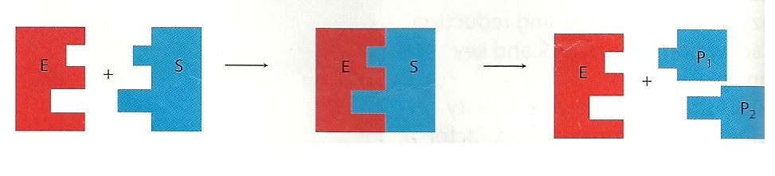

I II III IV V

Vi

1. The enzyme-substrate complex is represented by:
2. I and II
3. III
4. V and Vi only
5. IV, V and Vi
6. The products of this reaction are represented by:
7. I and II
8. III
9. V and Vi only
10. IV, V and Vi
11. Cells are small in size in order to create a:
12. large amount of cytoplasm for cellular reactions.
13. small amount of cytoplasm for cellular reactions.
14. large surface area to volume ratio.
15. small surface area to volume ratio.
16. Which of the following statements concerning enzyme action is correct?
17. Enzymes work within a narrow set of temperature and pH conditions.
18. Enzymes act to increase the activation energy needed for a reaction to proceed.
19. A specific enzyme can act on a wide variety of substances
20. Some enzymes act to slow down chemical reactions.
21. The formation of ATP during aerobic respiration is best represented by:
22. glucose+ oxygen → carbon dioxide+water + 38ATP
23. glucose+ oxygen → carbon dioxide+water + 2ATP
24. glucose+ carbon dioxide → carbon dioxide+water + 2ATP +lactic acid
25. glucose+ oxygen → carbon dioxide+water + 26ATP

**End of Section 1 – See below for Section 2**

**Section 2: Short answer (30 marks)**

This section has four questions. Answer all questions. Write your answers in the spaces provided.

**Question 11 (7 marks)**

Parts (a) and (b) of this question refer to the diagram below which shows a generalised cell.

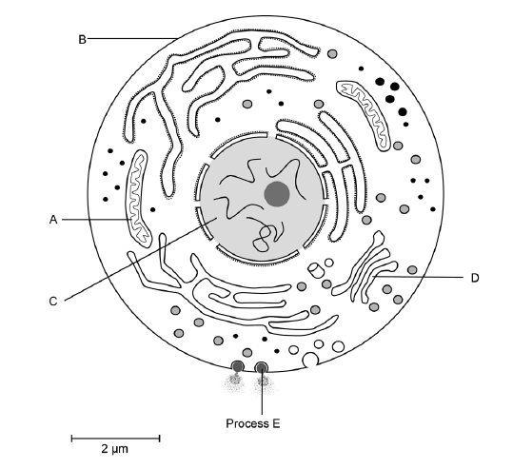

1. Complete the following table.

|  |  |  |
| --- | --- | --- |
| **Organelle** | **Name** | **Function** |
| **A** |  |  |
| **B** |  |  |
| **D** |  |  |

(6 marks)

1. Process E as labelled on the diagram shows the movement of a substance out of the cell via a vesicle. What name is given to this process?

________________________________________________________________________

(1 mark)

**Question 12 (13 marks)**

Complete cellular respiration is an enzyme-controlled chemical reaction that provides cells with energy.

1. Identify the role of ATP in cell metabolism.

________________________________________________________________________

(1 mark)

1. Complete the chemical equation below, which represents the breakdown of ATP.

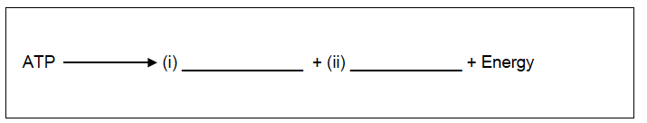

(2 marks)

1. List two cellular uses for energy.

One: ________________________________________________________________________

Two: ________________________________________________________________________

(2 marks)

The diagram below shows the mitochondrion of a skin cell and of a muscle cell.

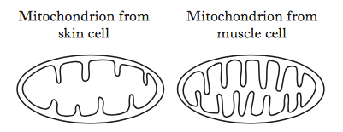

1. Explain the benefit of the mitochondrion of the muscle cell having a more folded inner membrane.

________________________________________________________________________

________________________________________________________________________

(2 marks)

The following diagram shows the steps involved in the partial breakdown of glucose in muscle cells.

Process A Process B

glucose 🡪 substance X 🡪 lactic acid

1. Name process A

________________________________________________________________________

(1 mark)

1. What name is given to substance X?

________________________________________________________________________

(1 mark)

1. Using examples, describe the difference between a catabolic reaction and anabolic reaction.

|  |  |  |
| --- | --- | --- |
|  | **Catabolic reaction** | **Anabolic reaction** |
| **Description** |  |  |
| **Example** |  |  |

(4 marks)

**Question 13 (4 marks)**

The table below states the types of different tissue found in the body.

Complete the table by filling in the information on the function of each type of tissue and provide an example of where it can be found in the body.

|  |  |  |
| --- | --- | --- |
| **Type of tissue** | **Function** | **Location in Human Body** |
| **Connective** |  |  |
| **Muscular** |  |  |
| **Epithelial** |  |  |
| **Nervous** |  |  |

4 marks)

**Question 14 (6 marks)**

Invertase is a human enzyme that breaks down sucrose into two products- glucose and fructose. It works best in neutral conditions.

The diagram below shows four test tubes.

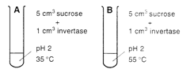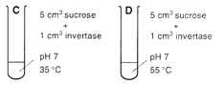

1. In which of the test tubes above would you expect glucose to be detected first?

________________________________________________________________________

(1 mark)

1. Explain why you chose this test tube.

________________________________________________________________________

________________________________________________________________________

(2 marks)

1. Explain why the enzyme amylase would not have been effective in carrying out this reaction.

________________________________________________________________________

________________________________________________________________________

(1 mark)

1. List two variables that would be controlled during this experiment.

_________________________________________________________________________

_________________________________________________________________________

(2 marks)

**End of Section 2 – Turn over for Section 3**

**Section 3: Extended answer (10 marks)**

This section has one question. Write your answers in the spaces provided.

**Question 15**

For the cells of a body to function normally, they must remain in a stable environment. Describe the structure of the cell membrane and explain how it allows for the exchange of ions to occur.

_____________________________________________________________________________

_____________________________________________________________________________

_____________________________________________________________________________

_____________________________________________________________________________

_____________________________________________________________________________

_____________________________________________________________________________

_____________________________________________________________________________

_____________________________________________________________________________

_____________________________________________________________________________

_____________________________________________________________________________

_____________________________________________________________________________

_____________________________________________________________________________

_____________________________________________________________________________

_____________________________________________________________________________

_____________________________________________________________________________

_____________________________________________________________________________

_____________________________________________________________________________

_____________________________________________________________________________

_____________________________________________________________________________

_____________________________________________________________________________

_____________________________________________________________________________

_____________________________________________________________________________

_____________________________________________________________________________

_____________________________________________________________________________

_____________________________________________________________________________

_____________________________________________________________________________

_____________________________________________________________________________

_____________________________________________________________________________

_____________________________________________________________________________

_____________________________________________________________________________

_____________________________________________________________________________

_____________________________________________________________________________

_____________________________________________________________________________

_____________________________________________________________________________

_____________________________________________________________________________

_____________________________________________________________________________

_____________________________________________________________________________

_____________________________________________________________________________

_____________________________________________________________________________

_____________________________________________________________________________

_____________________________________________________________________________

_____________________________________________________________________________

_____________________________________________________________________________

_____________________________________________________________________________

_____________________________________________________________________________

_____________________________________________________________________________

_____________________________________________________________________________

(10 marks)

**End of Test**